NAMA : RIFAL FEBIYAN (2100018345)

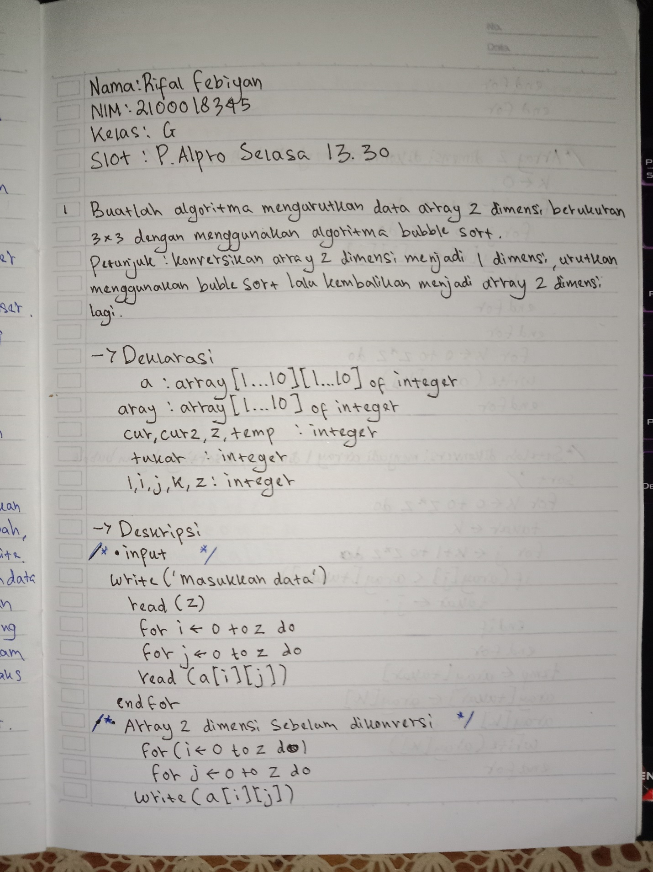

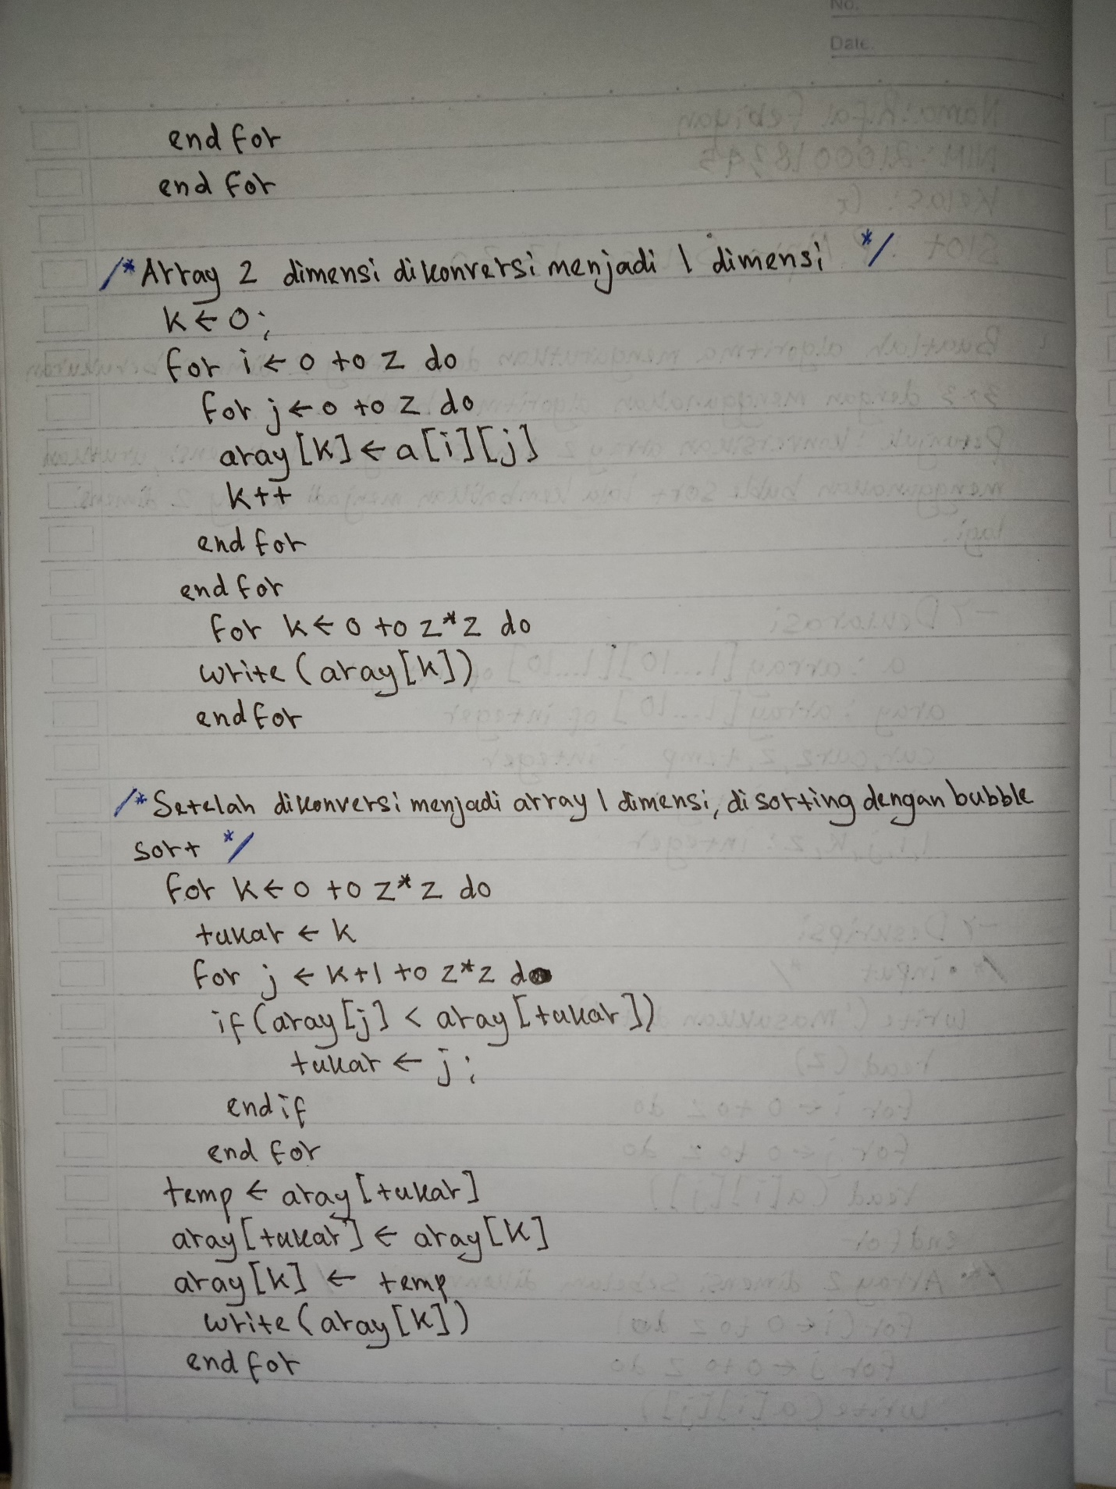

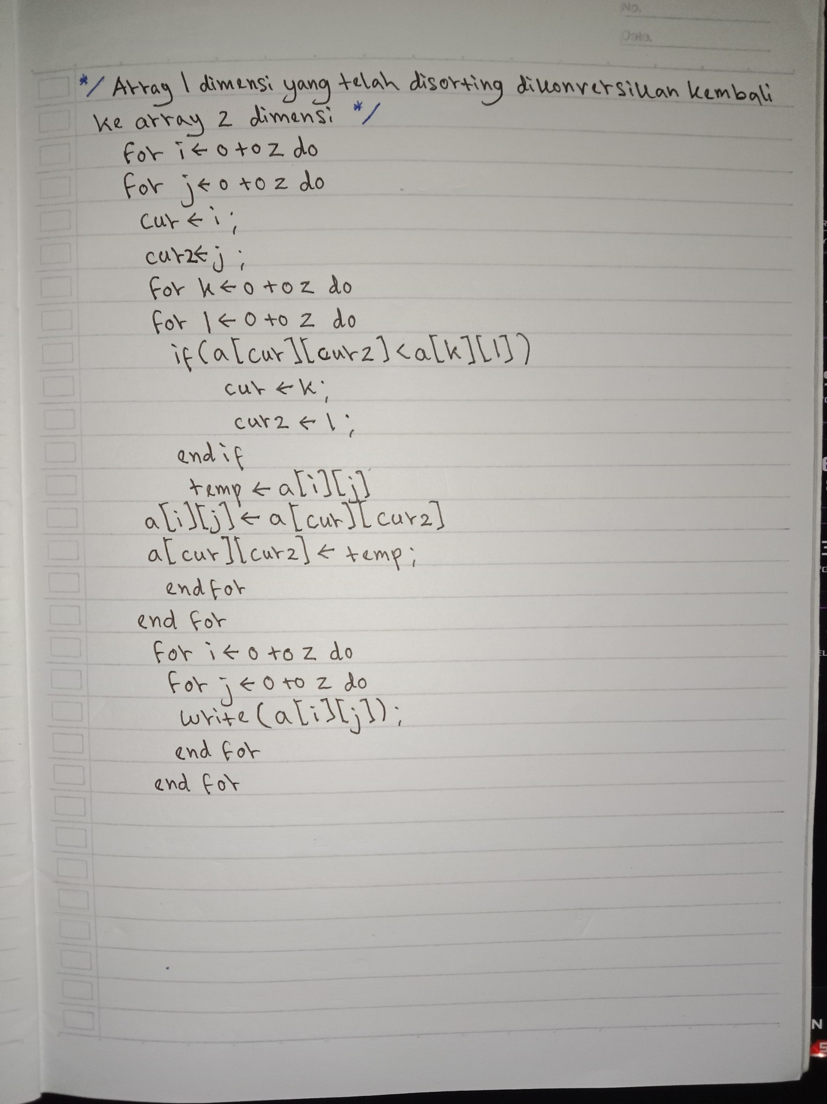

* Source code Pada Dev C++

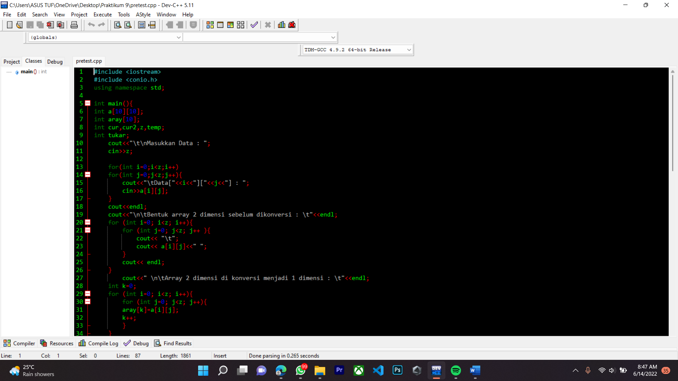

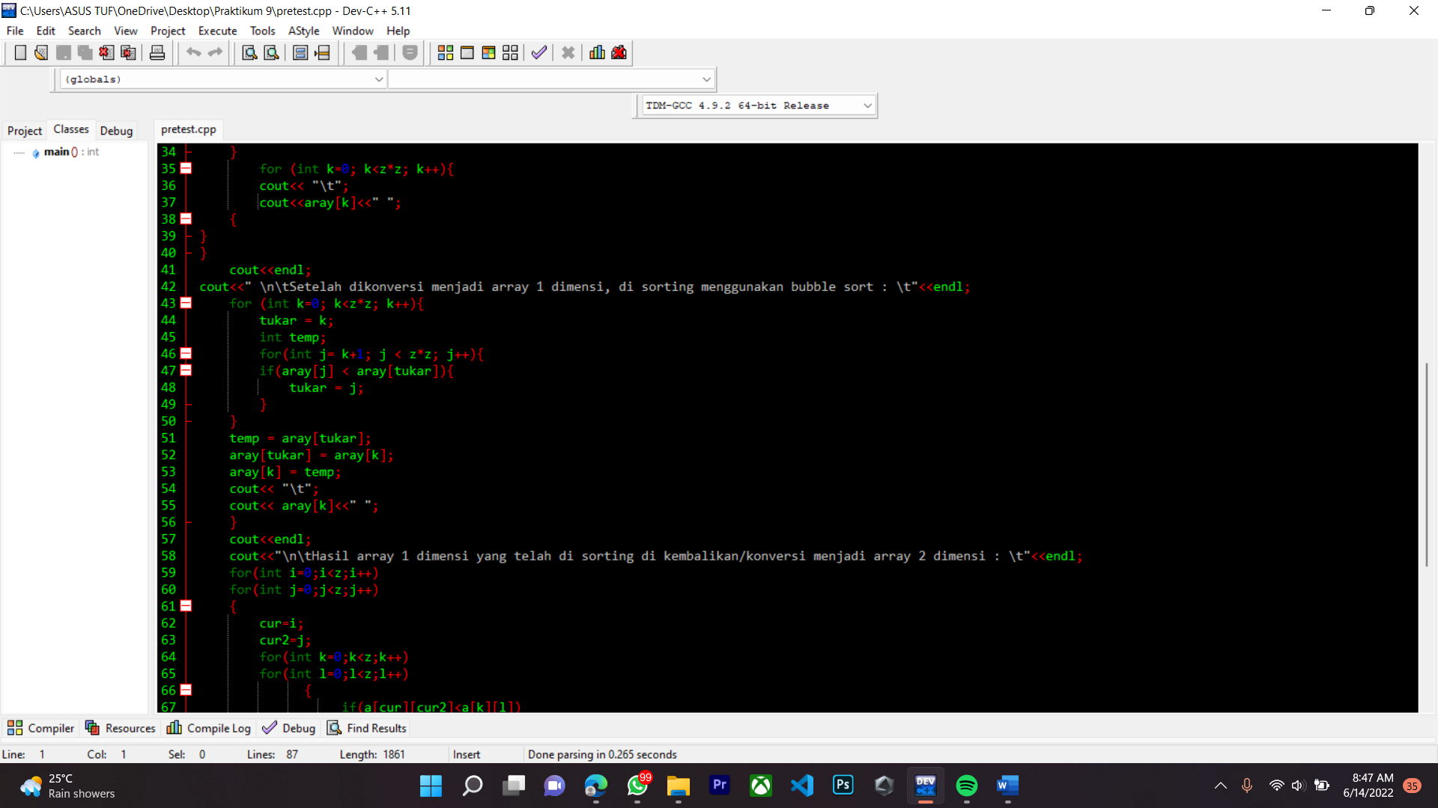

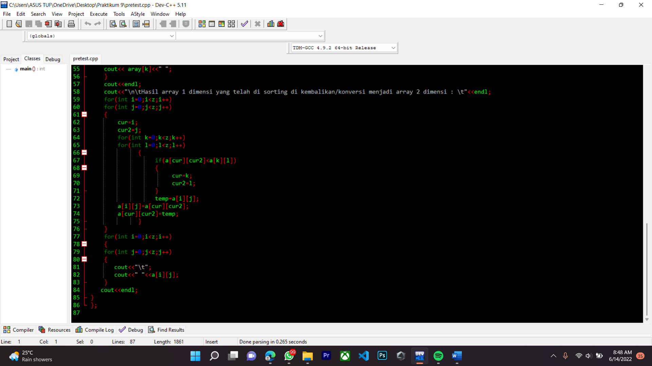

* Hasil running Pecobaan ke-1

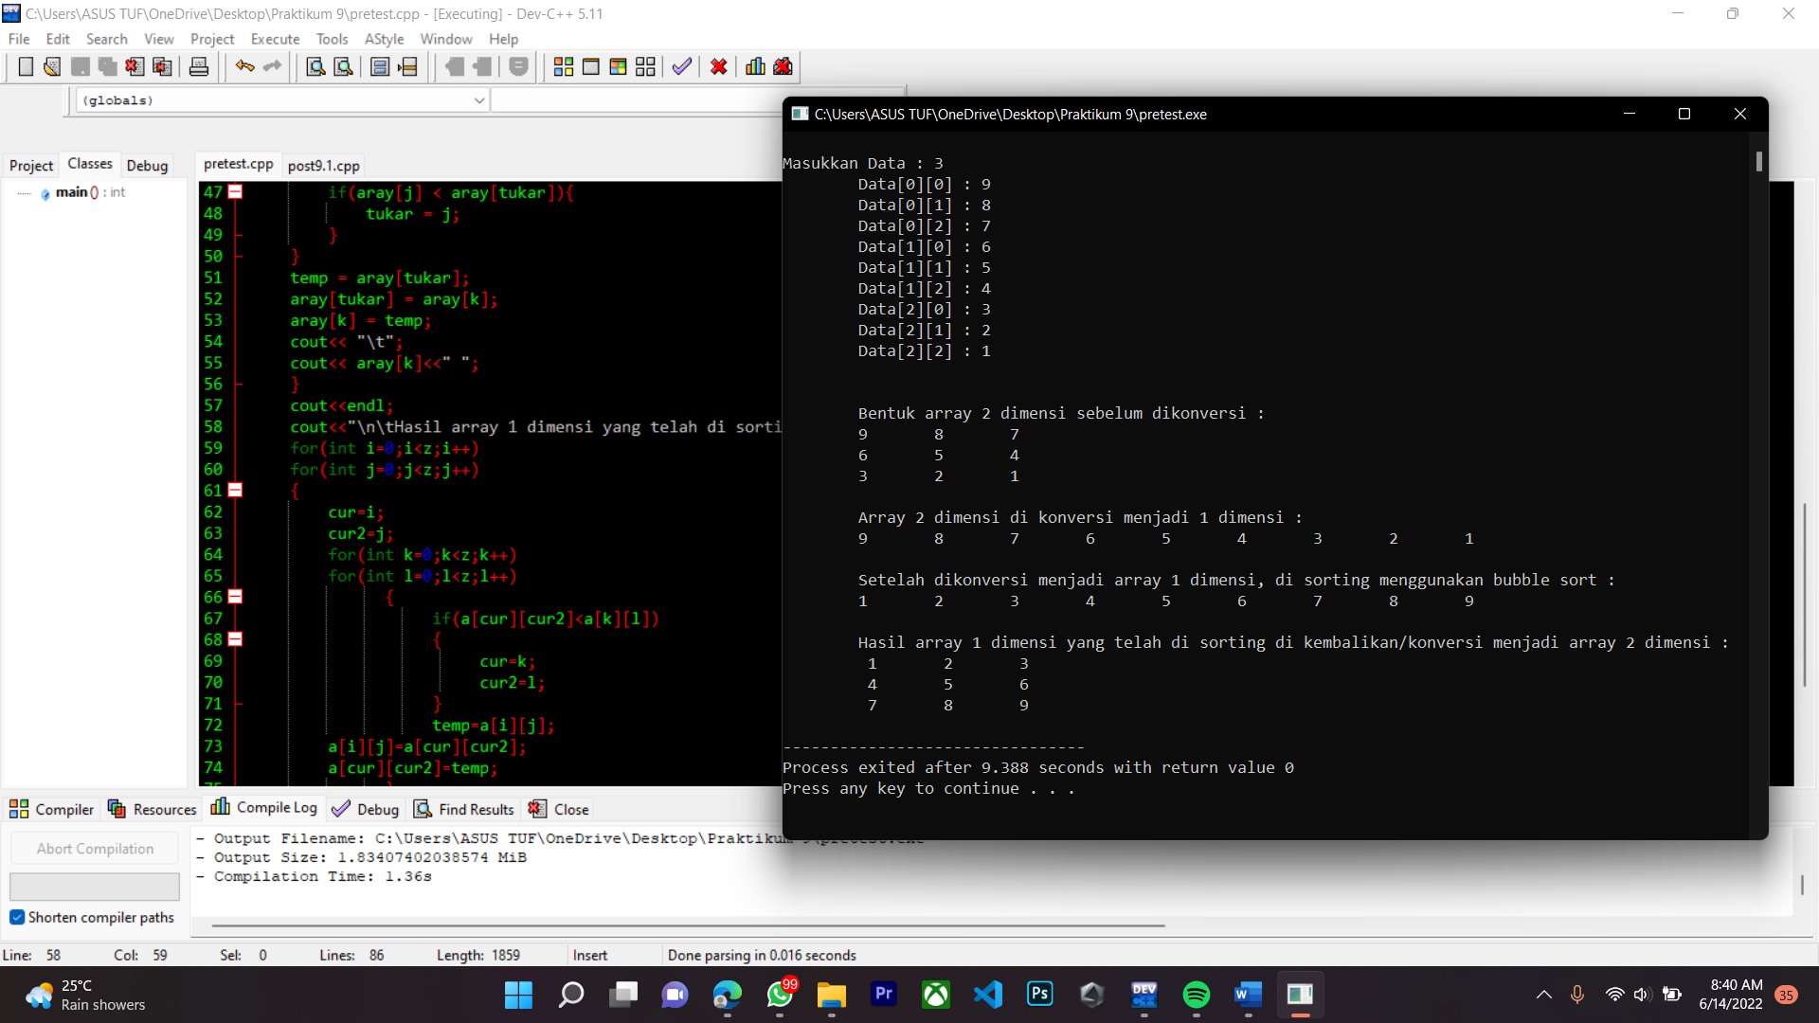

* Hasil running percobaan ke-2

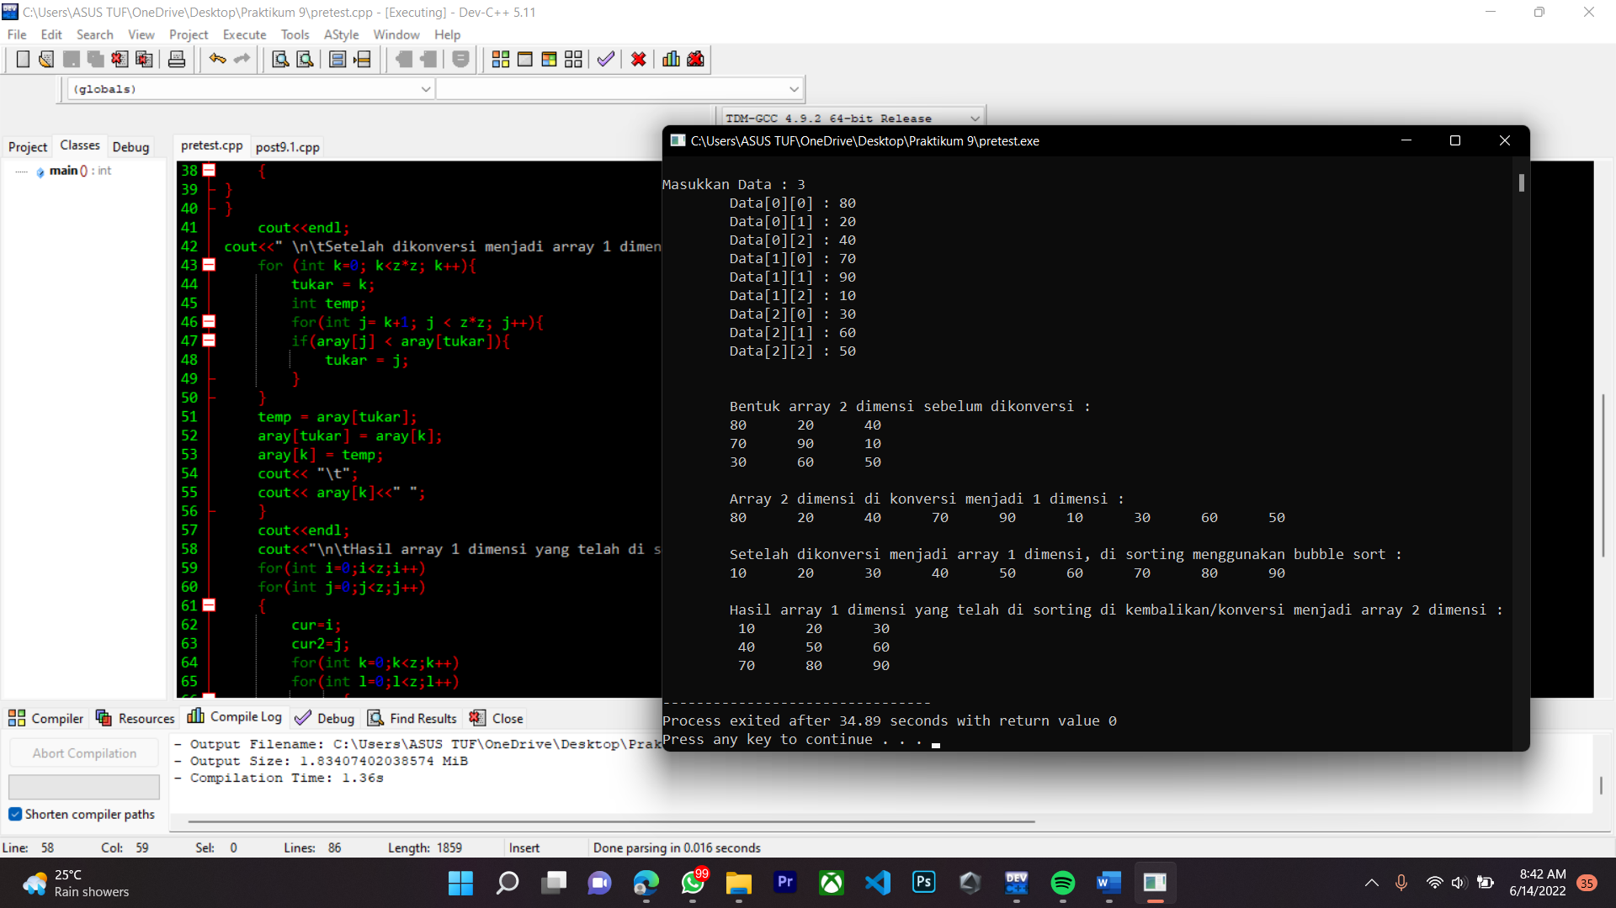

Source Code

|  |
| --- |
| #include <iostream>  #include <conio.h>  using namespace std;  int main(){  int a[10][10];  int aray[10];  int cur,cur2,z,temp;  int tukar;  cout<<"\t\nMasukkan Data : ";  cin>>z;    for(int i=0;i<z;i++)  for(int j=0;j<z;j++){  cout<<"\tData["<<i<<"]["<<j<<"] : ";  cin>>a[i][j];  }  cout<<endl;  cout<<"\n\tBentuk array 2 dimensi sebelum dikonversi : \t"<<endl;  for (int i=0; i<z; i++){  for (int j=0; j<z; j++ ){  cout<< "\t";  cout<< a[i][j]<<" ";  }  cout<< endl;  }  cout<<" \n\tArray 2 dimensi di konversi menjadi 1 dimensi : \t"<<endl;  int k=0;  for (int i=0; i<z; i++){  for (int j=0; j<z; j++){  aray[k]=a[i][j];  k++;  }  }  for (int k=0; k<z*z; k++){  cout<< "\t";  cout<<aray[k]<<" ";  {  }  }  cout<<endl;  cout<<" \n\tSetelah dikonversi menjadi array 1 dimensi, di sorting menggunakan bubble sort : \t"<<endl;  for (int k=0; k<z*z; k++){  tukar = k;  int temp;  for(int j= k+1; j < z*z; j++){  if(aray[j] < aray[tukar]){  tukar = j;  }  }  temp = aray[tukar];  aray[tukar] = aray[k];  aray[k] = temp;  cout<< "\t";  cout<< aray[k]<<" ";  }  cout<<endl;  cout<<"\n\tHasil array 1 dimensi yang telah di sorting di kembalikan/konversi menjadi array 2 dimensi : \t"<<endl;  for(int i=0;i<z;i++)  for(int j=0;j<z;j++)  {  cur=i;  cur2=j;  for(int k=0;k<z;k++)  for(int l=0;l<z;l++)  {  if(a[cur][cur2]<a[k][l])  {  cur=k;  cur2=l;  }  temp=a[i][j];  a[i][j]=a[cur][cur2];  a[cur][cur2]=temp;  }  }  for(int i=0;i<z;i++)  {  for(int j=0;j<z;j++)  {  cout<<"\t";  cout<<" "<<a[i][j];  }  cout<<endl;  }  }; |